Python assignment 1

1. Declare an integer variable 'a' with the value 10 and a float variable 'b' with the value 3.14. Print their sum.

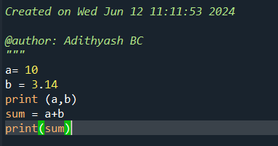



1. Assign the value 'True' to a variable 'is_valid' and the value 'False' to a variable 'is_empty'. Print both variables.

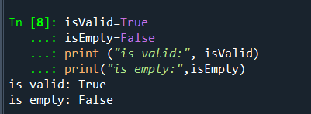

3. Create a complex number variable 'c' with the value '2 + 3j' and print its real and imaginary parts.

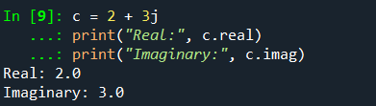

4. Declare a byte variable 'byte_data' with the value "b'hello'"and print its length.

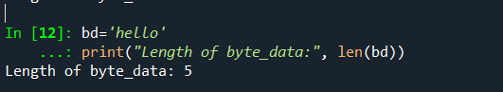

5. Create a 'bytearray' variable 'byte_array' initialized with the byte sequence "b'\x01\x02\x03'". Modify the first byte to '0x04' and print the modified 'bytearray'.

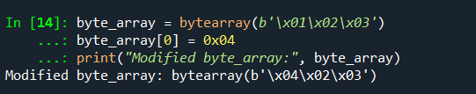

6. Convert the integer '255' to a binary string using the 'bin' function and print the result.

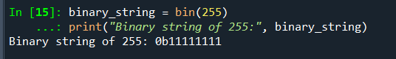

7. Given two Boolean variables 'x = True' and 'y = False', print the result of the logical 'AND' operation between 'x' and 'y'.

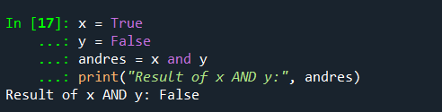

8. Assign the result of '5 > 3' to a variable 'result' and print its type.

9. Create a float variable 'pi' with the value '3.141592653589793' and round it to 4 decimal places. Print the rounded value.

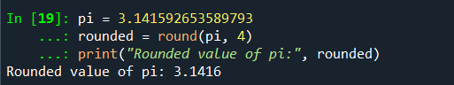

10. Assign the hexadecimal value '0x1A' to an integer variable 'hex_value' and print its decimal equivalent.

